Class 1

High-Level Framework
- Operations management is executing the day-to-day of a firm, while Operations strategy is setting the long-term playbook
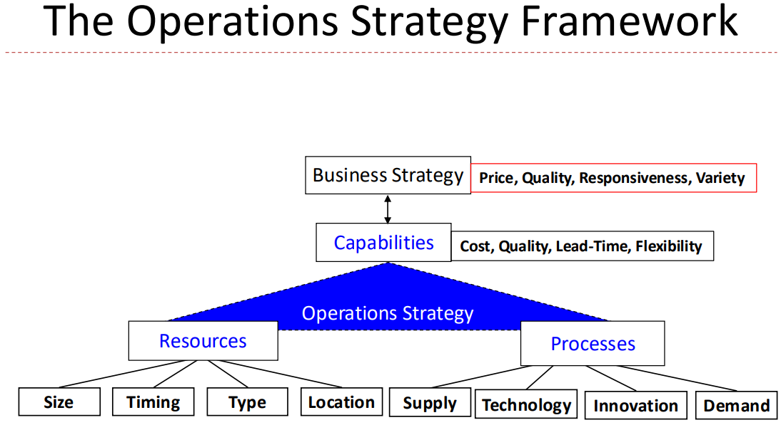
- Types of Resource Production
  - Project (1-off, unique projects)
  - Repetitive (most CPGs use repetitive production lines)
  - Batch (like repetitive, but made in batches of a certain quantity)
  - Continuous (e.g. petroleum processing)
  - Job Shop (different path for each person -> e.g. grocery store); has flexibility and each has different processes, but all still in the same place
- Key decision for supply processes is whether to outsource or make in-house

Alignment
- SOA: strategic operational audit
  - Firms should continually assess current resources and processes and together what capabilities you can actually generate. Then take the capabilities and determine what value prop you can actually deliver
- OMM: Product-Process Matrix
  - Matrix between process flexibility and product variety -> zone of alignment is from bottom left to top right
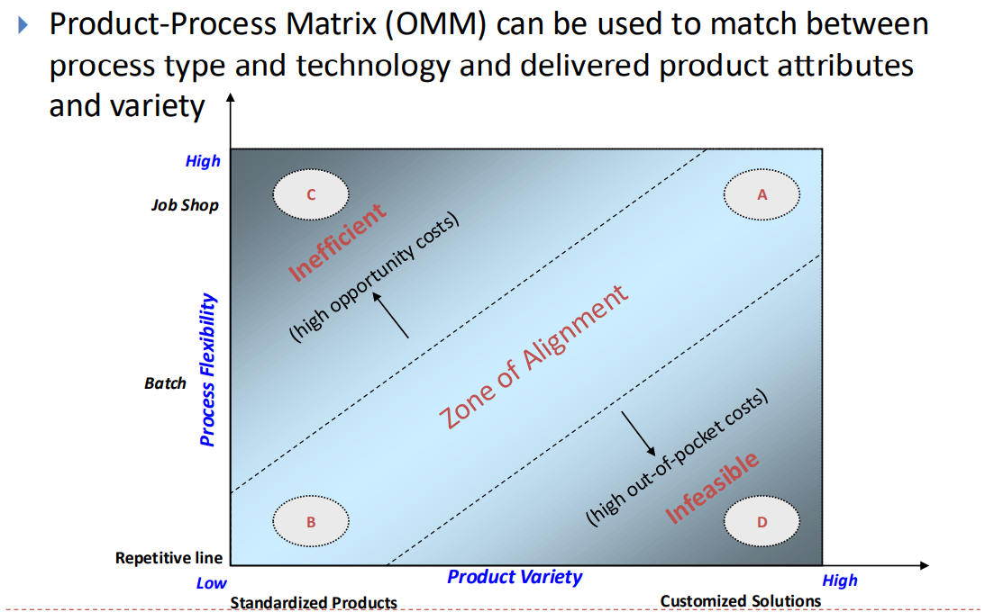
- Once we have the fundamentals down, we need to choose the operational system that achieves the highest NPV for the firm

